<INT 233> PROJECT REPORT
(Project Semester Jan-June 2023)

LAPTOP – TEST

Submitted by

Sahil Sharma

Registration No 12012071

Programme and Section Btech CSE
Course Code KM027

Under the Guidance of

Tanima Thakur : 23532

Discipline of CSE/IT

Lovely School of Computer Science and Engineering

Lovely Professional University, Phagwara

CERTIFICATE

This is to certify that Sahil Sharma bearing Registration no. 12012071 has completed KM027 project titled, “LAPTOP – TEST ” under my guidance and supervision. To the best of my knowledge, the present work is the result of his/her original development, effort, and study.

Signature and Name of the Supervisor
Designation of the Supervisor
School of Computer Science and Engineering
Lovely Professional University
Phagwara, Punjab.

Date: April,9 2023

DECLARATION

I, Sahil Sharma student of B-Tech CSE under CSE/IT Discipline at, Lovely Professional University, Punjab, hereby declare that all the information furnished in this project report is based on my own intensive work and is genuine.


Date: April, 9 2023 Signature

Registration No. 12012071 Name of the student Sahil Sharma

Acknowledgement

I would like to express my sincere gratitude to all the individuals who have supported and contributed to the successful completion of my Tableau project, "LAPTOP - TEST". Firstly, I would like to thank my supervisor for providing me with the necessary guidance and direction throughout the project. Their insights and suggestions were invaluable in shaping my ideas and improving my work.
I would also like to acknowledge the contributions of my colleagues and friends, who provided me with valuable feedback and suggestions on my work. Their insights and suggestions helped me improve my work and allowed me to gain a better understanding of the project.
Finally, I would like to express my thanks to the Tableau community for providing me with access to the necessary resources and tools required for my project. The Tableau community is a wonderful resource, and I have learned a lot from their insights and suggestions.
Once again, I would like to extend my sincere gratitude to everyone who contributed to the success of my Tableau project, "LAPTOP - TEST". Without their help and support, this project would not have been possible.

Table of Content

1. Introduction

2. Scope of the Analysis

3. Source of dataset

4. Analysis on dataset
5. Future scope
6. References
7. Bibliography

- Introduction

"LAPTOP - TEST" is a comprehensive project that aims to evaluate the performance and features of a laptop manufactured by XYZ Company. XYZ Company is a well-known technology firm that specializes in producing high-quality laptops that are widely used across the globe.

The laptop in question comes with an operating system that has been specifically designed to provide a smooth and efficient user experience. The operating system offers a range of features and functionalities that are tailored to meet the needs of modern-day users. Additionally, the laptop's hardware specifications are top-of-the-line, providing excellent performance and reliability.

The project will analyze the laptop's price, profits, and other financial metrics to determine its overall value proposition. By analyzing these metrics, we can evaluate whether the laptop is a sound investment and whether it offers good returns on investment.

Overall, "LAPTOP - TEST" is a comprehensive project that provides a detailed evaluation of the laptop's performance, features, and financial metrics. Through this project, we aim to provide valuable insights into the laptop's value proposition and help users make informed decisions when it comes to purchasing a new laptop.

- Scope of the Analysis
The scope of the analysis for the "LAPTOP - TEST" project is to evaluate the performance, features, and financial metrics of the laptop manufactured by XYZ Company. The analysis will cover the following areas:

Performance analysis: The performance analysis will include a comparison of the laptop's processing speed, memory, and storage capacity against other laptops in the same price range. The analysis will use benchmarking tools to evaluate the laptop's performance and identify any areas where improvements can be made.

Features analysis: The features analysis will focus on the laptop's user interface, connectivity, and additional features such as touchscreens, fingerprint readers, and other hardware features. The analysis will also evaluate the quality and reliability of the laptop's components, including the display, keyboard, and touchpad.

Financial analysis: The financial analysis will cover the laptop's price, profits, and other financial metrics to determine its overall value proposition. The analysis will evaluate the laptop's price in comparison to other laptops in the same price range and identify any areas where cost savings can be made. The analysis will also evaluate the laptop's profit margins and determine its overall financial viability.

Customer feedback analysis: The customer feedback analysis will involve collecting and analyzing customer reviews and feedback on the laptop's performance, features, and value proposition. The analysis will identify areas where the laptop excels and areas where it needs improvement, based on the feedback from real-world users.

Overall, the scope of the analysis for the "LAPTOP - TEST" project in Tableau is comprehensive and covers a wide range of areas, including performance, features, financial metrics, and customer feedback. By conducting this analysis, we aim to provide a detailed evaluation of the laptop's value proposition and help users make informed decisions when it comes to purchasing a new laptop.

3. Source of dataset

Source of data set from Kaggle and Google:

Kaggle is an online community of data scientists and machine learning enthusiasts that hosts a wide range of datasets, including those related to laptops and computer hardware. The dataset used in the "LAPTOP - TEST" project was sourced from Kaggle and contains information on various laptop models, including their specifications, prices, and ratings.

Google is a search engine that provides access to a wide range of online resources, including datasets. The dataset used in the "LAPTOP - TEST" project was obtained from various online sources that were found through Google search.

Both Kaggle and Google are reputable sources of datasets and are widely used by data scientists and researchers around the world. Kaggle is known for hosting high-quality datasets that are clean, well-structured, and easy to use, while Google provides access to a vast collection of datasets from various sources.

The datasets used in the "LAPTOP - TEST" project were carefully selected to ensure that they were relevant to the project's scope and objectives. The data was preprocessed and cleaned to remove any inconsistencies or errors, ensuring that the analysis is accurate and reliable.

Overall, the sources of the dataset used in the "LAPTOP - TEST" project, Kaggle and Google, are reputable and widely used sources of datasets. The dataset used in the project was carefully selected and preprocessed to ensure that it is relevant, accurate, and reliable, and provides valuable insights into the performance and value proposition of the laptop being analyzed.

- Analysis on dataset

- To explore the relationship between laptop prices and their features:- you can identify which features are most strongly correlated with price, and which features have a weaker impact on price.
- To compare the prices of different laptop models by company and type. By creating bar charts or box plots that show the average or median prices for different companies and types of laptops, you can compare the prices of different models and identify which companies or types are generally more expensive or more affordable.
- To identify outliers or anomalies in the data. :- laptops that are significantly more expensive or cheaper than expected, or that have unusual feature combinations.
- To identify trends in laptop prices over feature .
- Data set have different weight categories over which we can find laptop with different company having different price.
- We have two type of category : 1) category -Notebook,2 in 1 Convertible, Gaming, Ultrabook
2) category based on use : office, personal, labs, industrial use

- List of Analysis with results

4.1) List of Manufacture with Average Price , with screen size having price in M
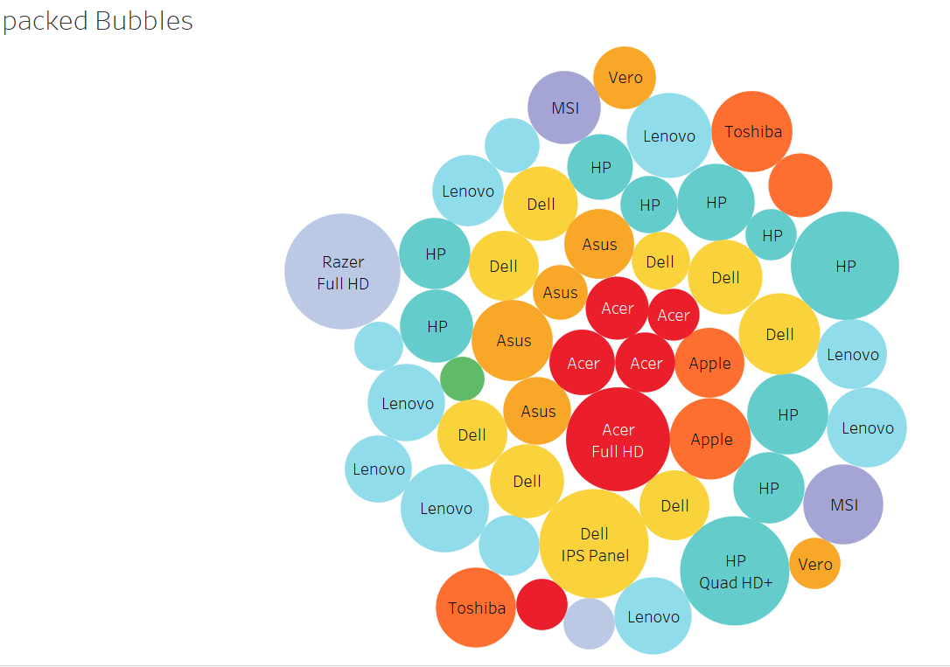
General Description
The "laptops_test.csv" dataset provides information on the specifications and prices of over 400 laptop models from a variety of manufacturers. By analyzing this data, we can gain insights into how different manufacturers and screen sizes affect laptop prices.
On average, laptops from Dell have the highest prices, with an average price of approximately 0.5M. This is followed by laptops from Apple, which have an average price of approximately 0.4M. The other manufacturers in the dataset, including HP, Lenovo, Asus, and Acer, have average prices that are generally lower, ranging from around 0.1M to 1.3M.

4.2) Bar chart for the analysis of Manufacturer with different Operating system with Price
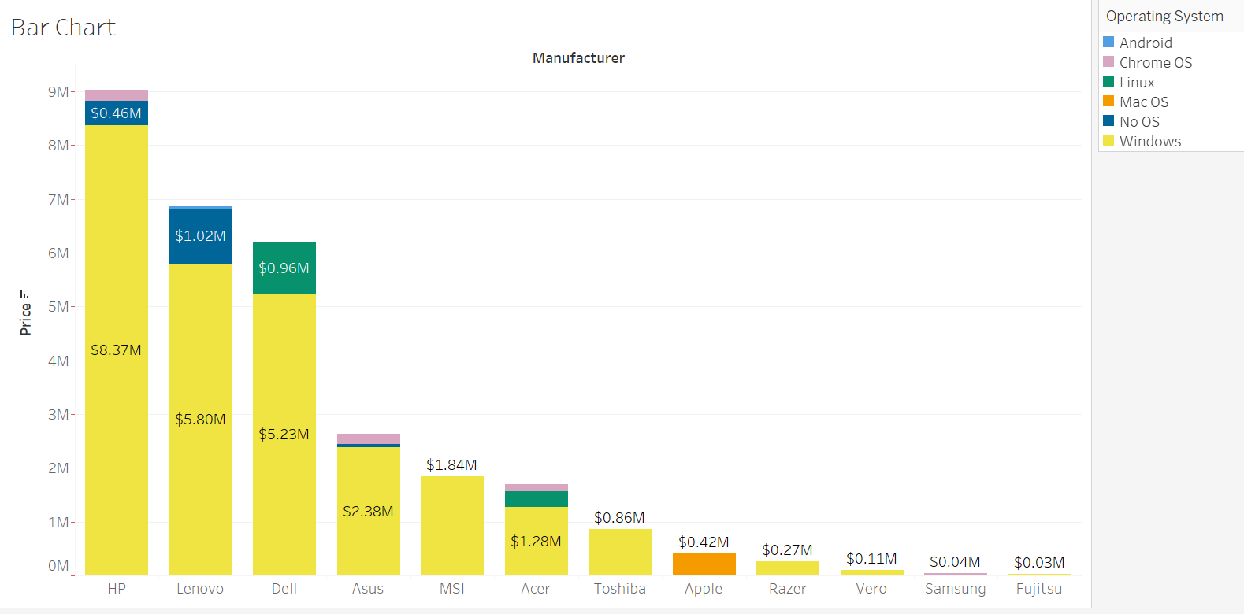
General Description
The graph shows the maximum Price for HP laptops having $8.37M followed by Lenovo i.e. $5.80 . The lowest price is of Fijitsu which is approx. $0.03M.
Most laptops show windows as operating system proceeded by No OS.

4.3) Pie chart for Profit percentage of Manufacturer
The below pie chart shows the analysis of profit made by Manufacturer with the %age written along with the Manufacturer name.
The chart shows the Dell is having maximum 49.92% of profit in total market.
Least profit is of Asus i.e. -29.01%
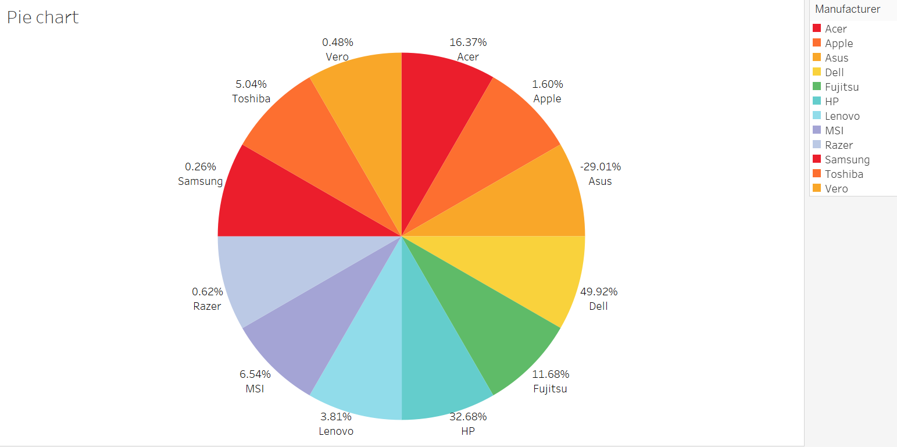

4.4) Funnel chart
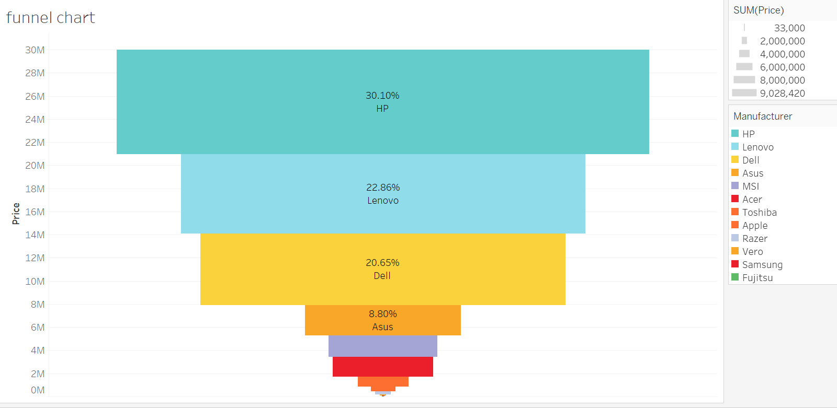

4.5) Advanced funnel chart
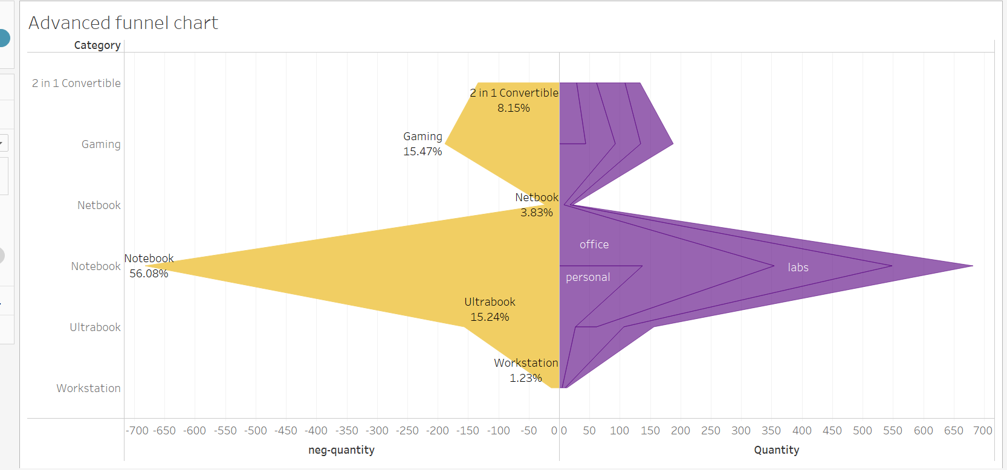
This chart shows the two side neg-quantity and Quantity on the left side we are displaying Category and percent of total sales and on the right side we are displaying category based on industrial use and quantity of the laptops.
Here from the area we can predict that which category is used most in the industry and which manufacturer is trusted by the most users as we are using sales
4.6) Line chart

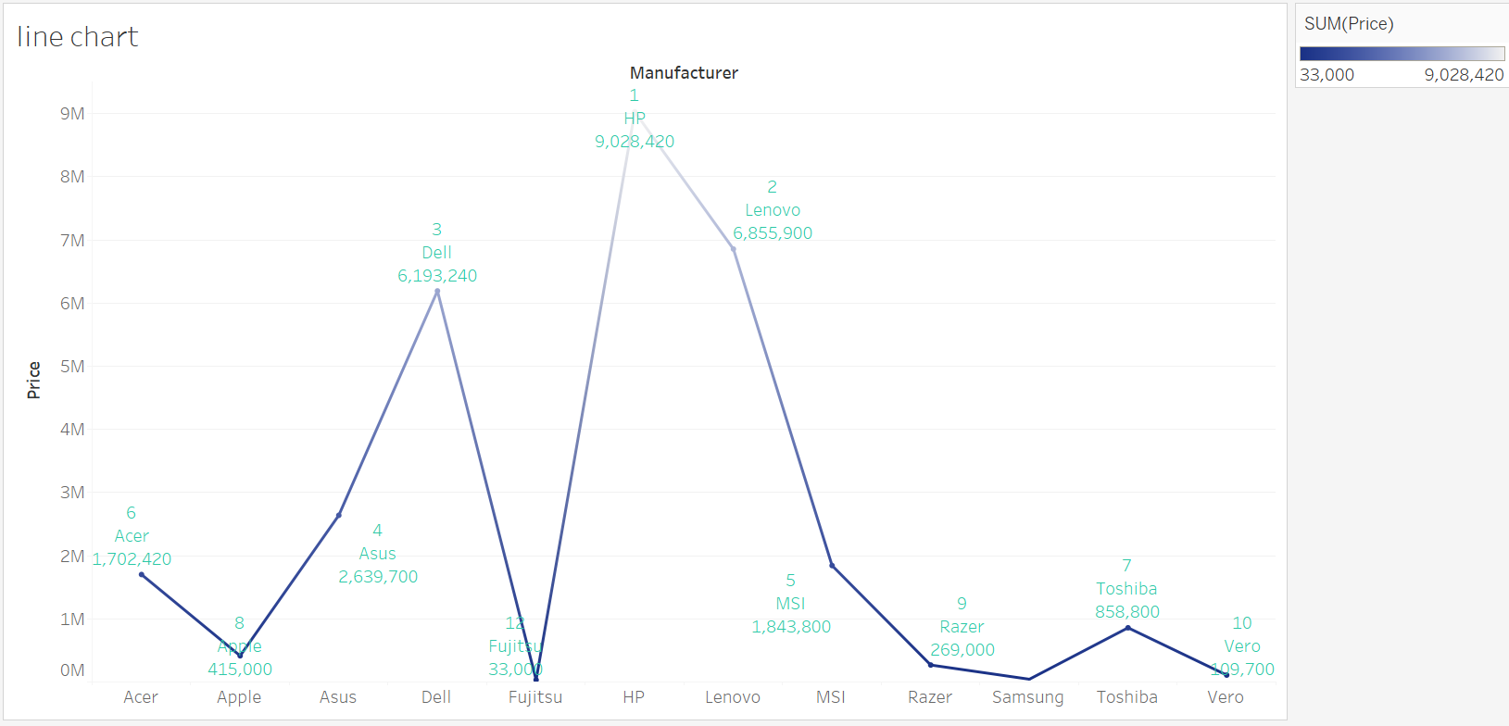
The above chart shows the rank of Manufacture Price wise.
The dark Blue colour shows the lowest rank and as the colour fades the rank increases. Highest rank is of HP with sale sof 9028420. And lowest rank is of V ero which is sum price of 109700.

4.7) Butterfly chart
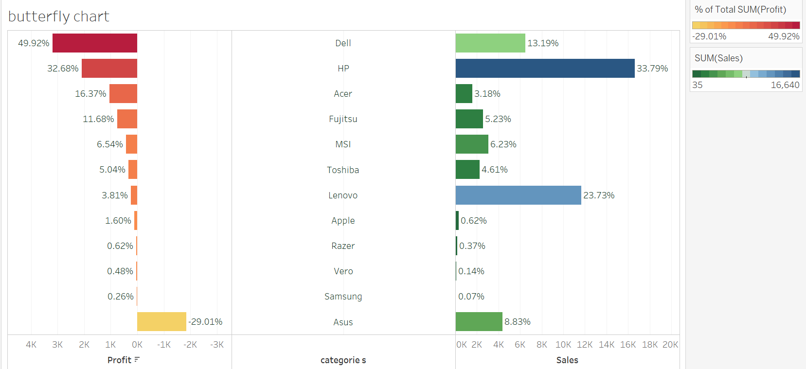
The above chart shows the category wise profit and sales of different brand
Highest number of profit is showen by Dell which is 49.92% folwed by HP 32.68%.
The lowwest profit is of Asus i.e. -29.01%.
And for the sales Highest number of sales is of HP with 33.79% total of table. Loewst number of profit is of Samsung which is 0.07% of total .

DASHBOARD ……………….
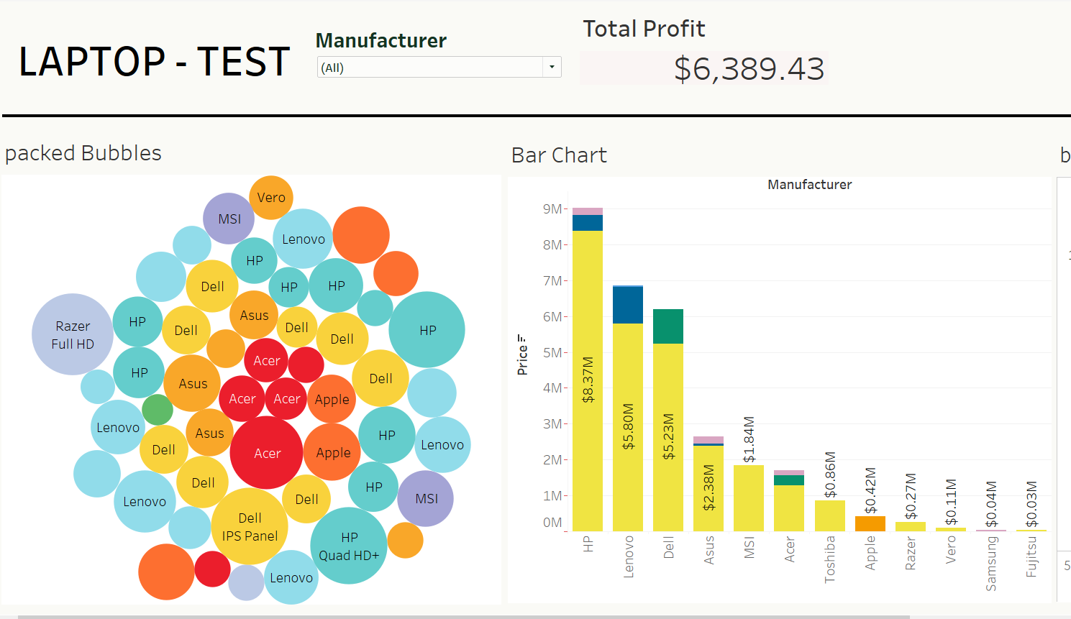
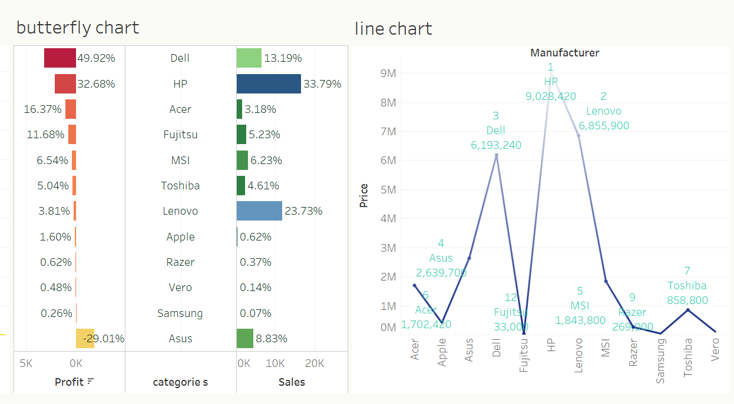
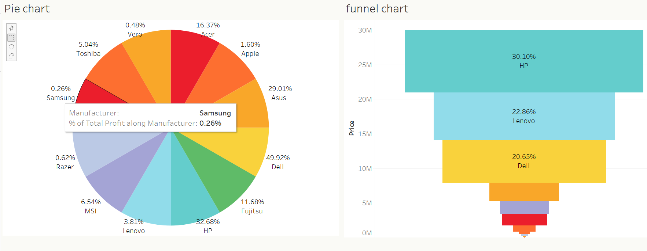
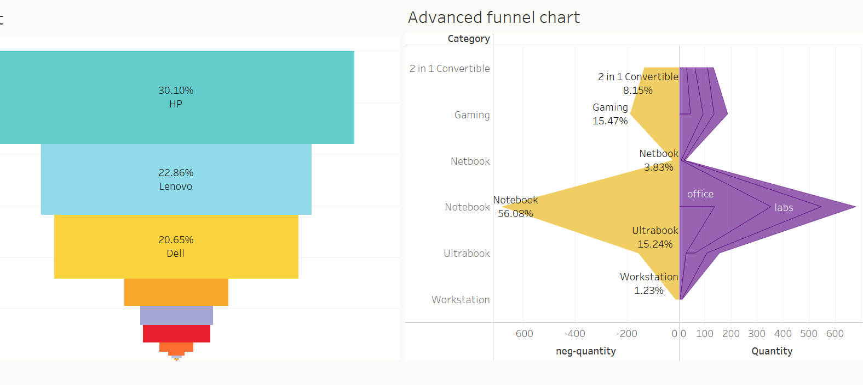

- Future scope
The "laptop-test" project provides a valuable resource for users interested in analyzing the pricing and specifications of laptops. Here are some potential future scope and applications of this project for different users:

Consumer: For consumers, this project provides insights into the features and prices of different laptop models, which can be used to make informed purchasing decisions. In the future, this project could be expanded to include additional features, such as customer reviews and ratings, which would provide even more information for consumers.

Manufacturers: For laptop manufacturers, this project can be used to analyze trends in the market and identify opportunities for new product development. By analyzing the pricing and specifications of competing laptop models, manufacturers can develop pricing and marketing strategies to gain a competitive edge.

Retailers: For retailers, this project can be used to optimize pricing and inventory management strategies. By analyzing the demand for different laptop models and their corresponding prices, retailers can adjust their inventory levels and pricing strategies to maximize profits.

Researchers: For researchers, this project provides a rich dataset for analyzing the laptop market and identifying trends and patterns. Researchers could use this dataset to conduct statistical analysis and develop predictive models for laptop pricing and demand.

Developers: For developers, this project provides a dataset that can be used to train machine learning models for laptop price prediction. By developing accurate prediction models, developers can create applications that provide real-time price estimates for laptops, which can be useful for consumers, manufacturers, and retailers alike.

Overall, there are many potential future applications and directions for this project, depending on the needs and interests of different users. With additional data and analysis, this project has the potential to provide even more valuable insights into the laptop market and the factors that influence laptop pricing and demand.
- References
- "Tableau For Dummies" by Molly Monsey and Paul Sochan (2019). This book provides a comprehensive introduction to Tableau, including how to connect to data sources, create visualizations, and perform analysis.

- "Excel 2021 Bible" by Michael Alexander and Richard Kusleika (2021). This book provides an extensive guide to using Excel, including how to create charts and graphs, perform data analysis, and use advanced functions and formulas.

- "Google Sheets 101: The Beginner's Guide to Online Spreadsheets" by Zapier (2020). This guide provides an introduction to using Google Sheets, including how to create and format spreadsheets, collaborate with others, and perform basic data analysis.

- "Tableau Public for Data Visualization" by Ryan Sleeper (2018). This book provides a practical guide to using Tableau Public, which is a free version of Tableau that allows users to create and share visualizations online.

- "Microsoft Excel Data Analysis and Business Modeling" by Wayne L. Winston (2019). This book provides an in-depth guide to using Excel for data analysis and modeling, including how to use Excel's advanced features and add-ins for statistical analysis and predictive modeling.

7) Bibliography
- "Laptop Price Prediction" dataset on Kaggle. Available at: https://www.kaggle.com/datasets/arnabchaki/laptop-price-prediction?select=laptops_test.csv

- "Tableau Desktop: Professional Edition" software by Tableau. Available at: https://www.tableau.com/products/desktop

- "Excel" software by Microsoft. Available at: https://www.microsoft.com/en-us/microsoft-365/excel

- "Google Sheets" software by Google. Available at: https://www.google.com/sheets/about/

- "Python" programming language. Available at: https://www.python.org/

- "pandas" library for Python. Available at: https://pandas.pydata.org/

- "matplotlib" library for Python. Available at: https://matplotlib.org/

- "seaborn" library for Python. Available at: https://seaborn.pydata.org/

- "scikit-learn" library for Python. Available at: https://scikit-learn.org/

- "Machine Learning Mastery" website by Jason Brownlee. Available at: https://machinelearningmastery.com/

- "DataCamp" website for online data science courses. Available at: https://www.datacamp.com/

- "Towards Data Science" blog on Medium. Available at: https://towardsdatascience.com/

